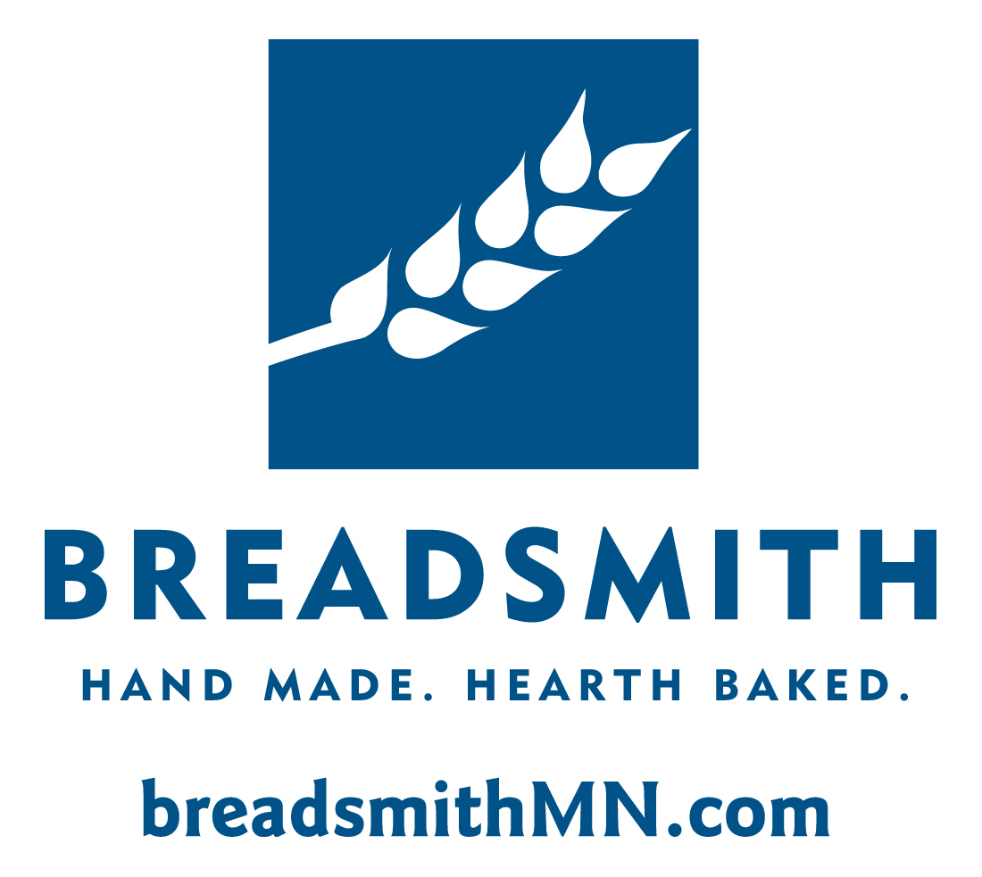Breadsmith, founded in 1994, is locally owned by David Wright (david@breadsmithMN.com).

The three locations are:

* Edina (50th and France)
* Minnetonka (near Ridgedale)
* St. Paul (Snelling and Grand Avenue)

Each bakery location is modeled after and inspired by a classic Parisian bakery. The goal is to achieve the French culture’s elevated love of visiting a local bakery for a baguette, boule or other daily bread.

Breadsmith is Kosher parve and dairy-free. Sourcing standard: great taste, fresh, local and authentic. Examples include:

* Blueberries: Fresh berries, only during their peak season, never frozen. They arrive in early June from Michigan’s Upper Peninsula.
* Flour: Unbleached, unbromated flour farmed from reliable non-GMO sources and milled in Winona.
* Peaches: Grown in Colorado and only used during a two-week window in mid-August when the harvested peaches are at their peak taste.

Breadsmith in the community:

* Long-time supporter of farmer’s markets including: Richfield and Maple Grove.
* Featured in a number of local restaurants including: St. Paul Hotel, BLVD and The General Store.
* Donates approximately 10,000 loaves each year to local organizations and special events.
* Bakery tours offer hands-on experiences for groups of all ages to make and bake baguettes.

**Tagline**

Hand Made. Hearth Baked.

**Mission**

To bring simple pleasures to our customers through made-from-scratch, hand-crafted, baked fresh daily breads.

**A Selection of Signature Bakery Items:**

* French Baguette and Boule
* Flaxseed Farmer’s Wheat
* Pumpkin Quick Bread
* Pretzel Buns and Breadsticks
* Lemon Lavender Muffins

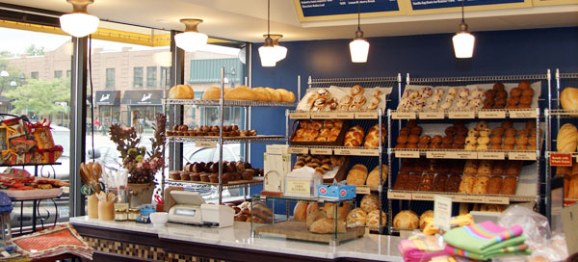 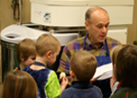

Edina Store Location Dave Wright

LEARN MORE AT: www.breadsmithmn.com

MEDIA RESOURCES AT: http://www.adsoka.com/mediacentral/breadsmith/